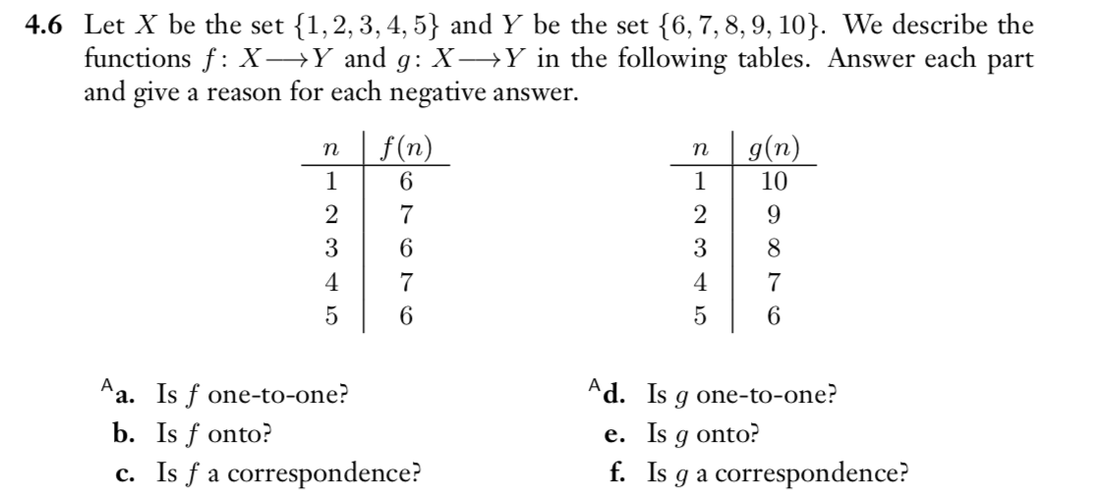

- F is not one-to-one because,

1 -> 6
3 -> 6
5 -> 6

2 -> 7
4 -> 7

B.
F is not onto because of the size of n > f(n).

C.
No, because the function is neither one-to-one or onto.

D. g is a one-to-one function because of all “n” maps to a unique output.
E. g is onto because the size of the n domain is the same size as its outputs.
F. g is correspondence because of its both one-to-one and onto.

